**Resume**

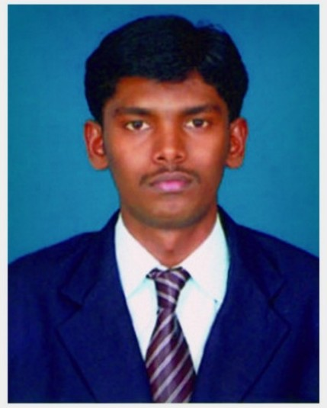

Senthil Nathan V

Contact No: +91 8796330366

E-mail Id: senthilnath90@gmail.com

**Career objective:**

Seeking a job in a company where I will have effective environment for knowledge and where I utilize my knowledge and skills, so that I can contribute to an organization and further enhance my professional skills.

**Educational profile:**

|  |  |  |  |  |
| --- | --- | --- | --- | --- |
| **Qualification** | **Institution** | **Year of Completion** | **University/**  **Board** | **Percentage** |
| B.E  (Mechanical) | Sona College of Technology,  Salem, Tamil Nadu | 2014 | Anna University | 7.75 (CGPA) |
| HSC | Ideal Hr.Sec School,  Erode, Tamil Nadu | 2010 | State Board | 82% |
| SSLC | Neelambal Subramainum Hr.Sec School, Salem, Tamil Nadu | 2008 | State Board | 81% |

**Software proficiencies:**

* Auto CAD, CATIA, Pro E/Creo & Solid Works.
* ANSYS (Basics).
* MS Office.

**Project details:**

**Title :** Automatic Glass Wall Cleaning Machine.

**Area of Project** **:** Engineering Design.

**Software used** **:** Pro E & CATIA.

**Description :** To design a new frame structure for glass wall cleaning machine to clean the glass automatically. The frame structure assembled with cleaning brush, electric motor, vacuum cups, vacuum distributor and pneumatic double acting cylinder. This machine can be used at any desired height for the cleaning i.e. to clean the glass walls on certain areas and also used on the inclined walls since the use of the static vacuum cups.

**Industrial exposure:**

* Visited [**HyundaiMotor India Ltd**](https://www.google.co.in/url?sa=t&rct=j&q=&esrc=s&source=web&cd=1&cad=rja&ved=0CC8QoAIwAA&url=http%3A%2F%2Fwww.hyundai.com%2Fin%2Fen%2Fmain%2F&ei=f1QbUpDIBcaNrQeU5oH4BA&usg=AFQjCNFthymtzElfJs0l4lN7BHlncl4aAg&sig2=jIW3OWmEhi0JDBuRGD0SWg)**, Sriperumbudur** andlearnt about **Engine Assembly**.
* Visited **Shard low Indian Ltd, Hosur** andlearnt about the **Manufacturing of Engine Crank Shaft**.
* Undergone In plant training in **SAIL, Salem** andlearnt about the process of **Hot & Cold Rolling**.

**Professional affiliations:**

* Active member in **Society of Automotive Engineers (SAE)**.
* Active member in **Mechanical Engineering Association (MEA)**.

**Co-Curricular activities:**

* Won first prize in Ad-zap a management event in **MECHTRIX’12** held in Sona College of technology.
* Won second prize in Multimedia Presentation titled **Production of Electricity from Exhaust Gas** in **MECHTANS’12** held at Sona College of Technology.
* Organized a cultural fest **MECHTRIX’12** as an events coordinator held at Sona College of Technology.
* Undergone Infosys Campus Connect training program for a period of 5 days held at Sona College of Technology.

**Personal details:**

* **Father’s Name** : Mr A.Vijayan.
* **Current Location** : Greenfield Society, Jogeshwari East, Mumbai.
* **Residential Address** : 2-2/331, Indhira Nagar-2, Mohan Nagar (Po), Salem (Dt), Tamil Nadu-636030.
* **Date of Birth** : 02/04/1991.
* **Gender**  : Male.
* **Languages Known** : English & Tamil.
* **Hobbies & Interests**  : Surfing in Internet, Playing Chess & Watching Discovery Channels.

I do hereby declare that all the information furnished above is true to my conscience.

Date : 20/06/2014.

Place : Mumbai.

(Senthil Nathan)